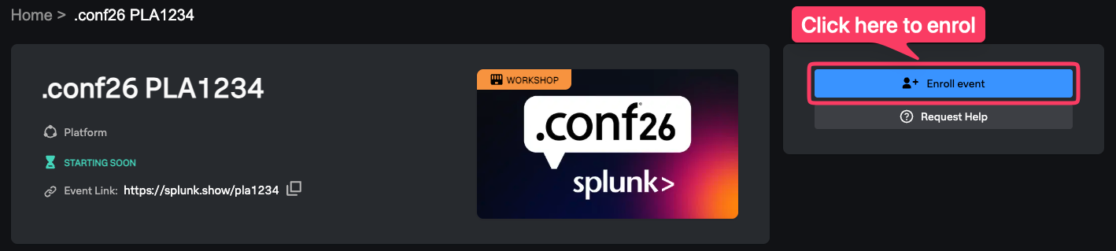
OBS1184
Advanced Collector Delta
Workshop skeleton | Single-agent Collector flow
Purpose: align the workshop team on the participant journey and section structure. The complete attendee procedure is maintained in the Markdown lab guide, not in this skeleton.

Session flow
# | Participant stage | Time
1 | Pair, register for Observability Cloud Free, and open the online guide | 5 min
2 | Download binaries and stage the local or remote environment | 5 min
3 | Start one Collector and loadgen; optionally enable cloud export | 10 min
4 | Upload and review agent.yaml in OTel Collector Config Builder | 5 min
5 | Reduce volume, add trace policy, and optionally add syslog | 15 min
6 | Export YAML, restart the Collector, and validate new telemetry | 15 min
7 | Take-home: Platform logs and profiling; wrap up | up to 5 min

Single-agent workshop design
The delta removes the old agent-to-gateway hop. One Collector owns the host metrics, traces, and logs pipelines, so participants make one configuration change and perform one restart.

Participant process model
otelcol --config agent.yaml
loadgen -correlated -health -security
There is no gateway.yaml, gateway listener, agent-to-gateway exporter, or second Collector process.

Environment paths
- Local macOS or Linux: the setup script stages a portable v0.157.0 Collector in advanced-collector-delta.
- Windows or restricted laptop: the participant uses a facilitator-provided Linux host over Session Manager or SSH.
- Cloud path: realm and organization token stay in local environment variables.
- Fallback path: --local-only disables cloud exporters and leaves telemetry in Collector debug output.

Required success evidence
- Host CPU, memory, and load metrics remain visible after optimization.
- New cinema-service traces arrive in APM when cloud export is enabled.
- New /_healthz spans are filtered and synthetic sensitive attributes are deleted or hashed.
- A correlated log preserves the application trace ID and span ID in local debug output.
Validation rule: Backend validation is required; local health alone does not prove ingestion.

Detailed flow skeleton

1. Pair, register, and open the guide - 5 minutes
Pairing is optional. Participants verify browser access and organization readiness. Anyone waiting for activation pairs with a working organization or uses the local-only path.

2. Download and stage - 5 minutes
The local path runs setup-workshop.sh on macOS or Linux. The remote path enters a prebuilt Linux directory. Both paths end with the same seven files and no gateway configuration.

3. Run and observe - 10 minutes
Participants start one Collector and one load generator. With realm and token set, they find host data in Infrastructure Monitoring and cinema-service traces in APM; otherwise they inspect local debug output.

4. Understand agent.yaml - 5 minutes
Participants upload the current agent.yaml to OTel Collector Config Builder and connect the component inventory to the metrics, traces, and logs pipelines.

5. Optimize in Config Builder - 15 minutes
Participants reduce host-metric volume and add trace filter/privacy processors. Syslog is optional and remains a logs take-home extension.

6. Apply and validate - 15 minutes
Participants export the complete YAML, replace agent.yaml, restart the same Collector, generate fresh telemetry, and prove each intended result.

7. Take-home and wrap-up - up to 5 minutes
The team points attendees to Splunk Platform log export with Log Observer Connect and to AlwaysOn Profiling with a supported application runtime.

Attendee guide source
The attendee-ready commands, Config Builder edits, fallback paths, validation checklist, and take-home details are maintained in this Markdown file:
content/en/ninja-workshops/foundations/2-opentelemetry-collector-workshops/
2-advanced-collector/lab-guide.md
Authoring boundary: Copy the reviewed Markdown procedure into the final lab-guide DOCX later. Do not expand this skeleton independently or the deliverables will drift.

Items to add during final authoring
- Final session ID, speaker names, and event-specific access instructions.
- Approved screenshots of OTel Collector Config Builder, Infrastructure Monitoring, and APM.
- Facilitator support contacts and the tested remote-host connection details.
- Final product-navigation labels after rehearsal in the attendee organization type.

